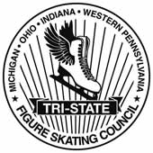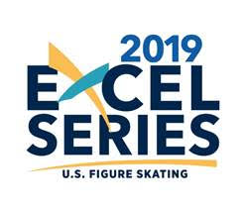

Registration is now open on EMS!

Join us at the Tri-State Memorial Figure Skating Championship presented by Arctic Figure Skating Club on
April 27-28, 2019
at Arctic Edge Arena in Canton, Michigan

Registration deadline is April 1, 2019. See below for instructions

REGISTRATION INSTRUCTIONS:
- Go to www.usfsaonline.org
  - For best experience, the Google Chrome browser is recommended
- Enter your U.S. Figure Skating or Learn to Skate Member number and password
  - If you need assistance with your member number and password, contact Member Services atmemberservices@usfigureskating.org.
- Click the blue EMS button
- Click “Competition Registration”
- Choose Tri-State Memorial from the list of competitions.
  - If you need assistance completing your registration, contactproductsupport@usfigureskating.org.

